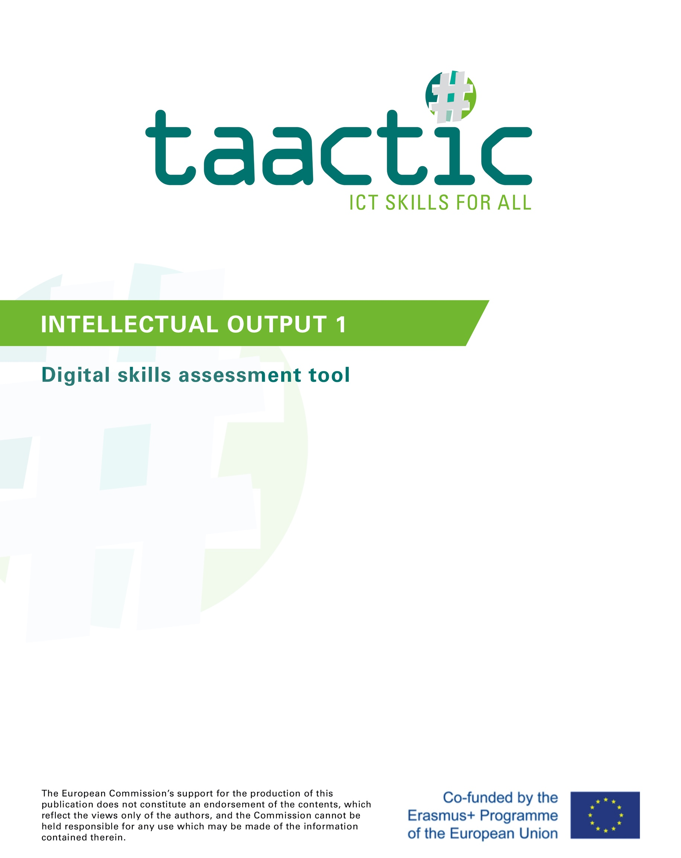

Introduction
The TAACTIC project aims to identify, develop and work towards recognition of basic digital skills of low-skilled adults in order to enable them to access the labour market sustainably.
Low-skills adults from vulnerable groups are particularly impacted by the digital divide and have troubles adapting to the labour market rapid changes. Moreover, the quick digitalisation of society and of our daily lives (public and private services, leisure, administrative procedures, shopping, etc.) causes many inequalities for those people, who therefore are even more marginalised.
TAACTIC aims to propose practical and operational responses to this challenge for VET centres in order to identify, develop and make visible the learning of digital skills with a view to better social inclusion, the pursuit of training pathways and sustainable access to quality employment for learners.
To achieve its objectives, TAACTIC is working on:
- Creating a positioning tool, to identify learners’ digital skills
- Defining a common reference framework for digital skills training, including a training module around digital skills
- Developing innovative pedagogical activities for Vocational Education and Training (VET) professionals and their learners
- Developing recommendations for training in the digital trades through the discovery of the digital trades of the future
- Providing a toolkit, bringing together existing educational resources to help organise training courses in digital professions.
My digital skills, a positioning tool
Skills assessment is one of the main and important elements when it comes to training and education. It generally takes place as soon as the learner starts their training path, in order to position the learner and their skills so as to build their professional project and adjust their training pathway. Skills assessment is used to support the learner, by enabling a "profile diagnosis" to be made. It is not a question of assessing the learner, or evaluating their skills, but well taking knowledge and seeing these skills.
My digital skills is a tool for positioning learners' digital skills developed as part of the TAACTIC project. It has been developed so that VET operators can systematically include a dedicated section on digital skills in their skills assessment process.
The purpose of our tool is to be used multiple times in the training programme, in order to observe the learner's progress and position their performance in terms of the mobilisation of digital skills and, as a result, to adjust the learning programme and the pedagogic actions to carry out with them.
This tool is based on the European framework of digital competences for citizens, DIGCOMP 2.0 and 2.1, which presents 5 digital competences areas :
- Information & Data litteracy
- Communication & Collaboration
- Digital content creation
- Safety & Privacy
- Problem solving
In the framework of TAACTIC, partners chose to focus particularly on DIGCOMP 2.1 levels 1 and 2, corresponding to the Foundation, or an elementary user, because the project targets low-skilled adults.
The partners made choices and selected, within this framework of competences, the most relevant competences to be tested (see table below). With this tool, the stance is to test by doing as much as possible, with practical exercises and concrete questions.
The criteria for creating the test was to generate a test:
- Providing a global vision of the learner's digital skills as soon as they start training
- Short and fast enough, while offering varied and focused questions
- A "simple" ready to use tool, that is very adaptable and modular
- Relevant and exploitable in all training contexts, regardless of the field or sector of training
The test questions were chosen with a view to skill positioning - gap detection, not skill assessment. The proposed exercises are therefore not directly linked to training objectives, but are designed on the basis of the competence areas listed in the DIGCOMP.
Getting to grips with the tool: tips and advice for adaptation
Our ambition for this tool was twofold. It was a question of creating a tool:
- Common and "universal" enough, which could be operational as it stands and used as is within a large number of education and vocational training organisations
- ... but which can be used as a reference framework, so that any interested training operator can easily modify it and adapt it to their training realities, and capitalise on our tool to develop a quality tailor-made tool
The tool is therefore useable as it is, but you are free to use it as you wish. During the development of the tool, we carried out a testing phase by collecting the opinions of professionals in the field on what we had created (trainers, pedagogical coordinators, training centres managers, etc.). Thanks to the involvement and feedback of these pedagogical experts, we were able to improve the tool. Some comments could not be incorporated into the final version, despite their relevance. Below, you will find a series of tips from the test, so that you can adapt the tool if you wish:
Operating system: We have opted to rely on the operating system and proprietary software, which are often paid for, as they are commonly used in VET organisations. The tool is therefore centred around Windows, Office Suite and other common software. However, if you work with vulnerable audiences, who may not have the opportunity to access paid licenses in the private sphere, it may be relevant to adapt the content by taking the option of free, open source, collaborative systems and software, ... On this subject, you can explore the logic and imagery of Linux & Ubuntu, Libre Office, Open Office, Mozilla Firefox, Framasoft, ...
Peripherals and media: Once again, a bias has been to test competences in the context of training and education, i.e. digital competences rather related to "office automation" than "citizenship competences". Therefore, we have rather thought of a tool centred on the use of a computer (fixed or portable). It may be relevant to adapt the test, in whole or in part, by changing certain questions (or adding new ones) centred around the elements and actions specific to tablets and smartphones. Similarly, you could put more emphasis on dematerialised storage and sharing systems (cloud, networks, online exchange platform, ...).
Understanding and basic skills: It is not uncommon in VET organisations to support illiterate audiences, or learners who do not have a sufficient command of the national language(s). In addition, some learners may also have cognitive impairments or different learning rhythms. For these learners, the test as it stands is not very practical. It may be if the learner is supervised by a trainer when taking the test. At best, the tool should be adapted by integrating more visuals (images, pictograms, etc.), by simplifying the instructions, by adapting the vocabulary and the level of language.
Content and themes: As things stand, the content and themes of the questions are "standardised". We have deliberately chosen sufficiently common cultural examples so that they can be understood by all. The test could be improved, in order to interest and motivate your learners more, by adapting the cultural references. For example, the test could be improved to make it more interesting and motivating for your learners by adapting the cultural references:
- Adapting European cultural references with national or regional references.
- Substitute cultural references with thematic references related to your organisation or the learners' training program.
- Change texts and cultural references into cultural references that are better known of your learners.
- Add or replace certain questions with themes and questions directly concerning adults in a socio-professional inclusion path: looking for job offers, writing applications, etc.
Level and skills: some parts of the tool may not seem very relevant to you. This is particularly the case for the section on spreadsheets. Several pedagogical experts who took part in the testing agreed with this. On the other hand, some felt that this section was a good introduction to the subject. So don't hesitate to keep or delete certain parts of the tool, as you wish, depending on your audience and your training objectives.
Testing: we thought of the tool as a condensed global tool. For some learners, or depending on the pace and the learning programme, you could split the test into several parts and submit it to the learners in several separate times.
Targeted skills
From the DIGCOMP framework, partners filtered and selected the competences they considered most relevant to be tested with learners from the target group. It is on this basis that the My Digital Skills tool was developed.
Below is the list of competences selected at level 1-2 (Elementary user):
- INFORMATION & DATA LITTERACY
1.1 Browsing, searching and filtering data, information and digital content | I am able to search for information online using a search engine.
1.2 Evaluating data, information and digital content | I'm able to find information. I know that the information available online is not always reliable.
1.3 Managing data, information and digital content | I can back up or store files or content (text, images, music, videos, web pages, etc.) and retrieve them once backed up or stored.

2. COMMUNICATION & COLLABORATION
2.1 Interacting through digital technologies | I can communicate with others by mobile phone, voice over IP (Skype, etc.), email or online chat - using basic functions (voice mail, SMS, sending and receiving email, text exchange, etc.).
2.2 Sharing through digital technologies | I can share files or content using simple tools
2.3 Engaging in online citizenship | I know that I can use digital technologies to interact with services (utilities, banks, hospitals, etc.).
2.4 Collaborating through digital channels | I know that there are social networking sites and online collaboration tools available.
2.5 Netiquette | I know that when using digital tools, certain rules of communication must be respected (e.g. when posting a comment or sharing personal information).
2.6 Managing digital identity | I know that sharing my private life on social networks is the same thing as making it public.

3. DIGITAL CONTENT CREATION
3.1 Developing digital content | I can create simple digital content (text, tables, images or audio files, etc.) in at least one format, using the digital tools
3.2 Integrating and re-elaborating digital content | I can make basic changes to content created by others. I am aware that the content may be protected by copyright.

4. SAFETY & PRIVACY
4.1 Protecting devices | I can take simple steps to protect my devices (e.g. using antivirus software or passwords).
4.2 Protecting personal data and privacy | I know that the information available online is not always reliable.  I know that my digital identity (username and password) can be stolen.
4.4 Protecting the environment | I know that extensive use of digital technologies can be harmful to my health.

5. PROBLEM SOLVING
5.1 Solving technical problems | I can find support and assistance when a technical problem occurs or when using a new device, program or application.
5.2 Identifying needs and technological responses | I know how to solve routine problems (e.g. close a program, restart a computer, reinstall or update a program, check an Internet connection)

The tool
The test takes place on a computer.
- In the tool file, on the last page, add your email address so that they can send you their answers when they have finished the test.
- Then send or share the document + the Excel file "EU 2019" with them.
The learner must open the document (alone, on instruction or open it with them to read it) and complete the requested exercises. The computer must be connected to the Internet.
We do not recommend a time limit for this assessment, but you can try to give them an estimate of the time. Depending on the level of the learner, an approximation can be placed between 30min and 1h for the completion of all the exercises.
Remember to reassure them that this is not an assessment. Explain to them the conditions and objectives for achieving this positioning: to situate their skills, to adapt the training.

My digital skills
This is a digital skills assessment, consisting of questions and exercises to practice and assess your digital skills.
Take the time to answer, and don't hesitate to call on a trainer if you need help to understand a question or complete an exercise.

DIGITAL ENVIRONMENT
1. What is the name of these computer parts and peripheral? Write the number in the corresponding case.
1. Computer 2. Mouse 3. Keyboard 4. USB Key 5. Printer

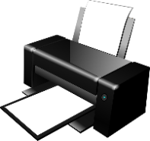 |  | 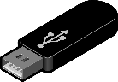 |  | 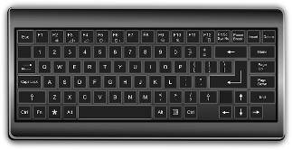
N°… | … | … | … | …

2. On which icon do you need to click to…
- Print :
- Finding or filing a document :
- Turn off the computer :
- Close a file or a page :
- Open a text document :
- Connect your computer to the Internet :

1 | 2 | 3 | 4 | 5 | 6

3. Is there a printer associated with this computer ? ...
- If that is the case, what is its name ? …..
4. What is the name of the Internet network this computer is connected to ? .....
- Is it a Wifi or Ethernet cable connection ? …..
5. On this computer, in the Files, create a New folder and name it ICT Assessment 2020.

INFO SEARCH

1. By searching on the Internet, answer the following questions:
- In what year was Robert Schuman, the founder of the European Union, born?
- What is the URL link of the European Parliament's website?
- What is the physical address of the European Parliament in Brussels?
- How far is the European Parliament in Brussels from the European Parliament in Strasbourg?

2. Which search engine did you use to answer these questions? ………..
3. Search for the European flag on the internet, then insert in this frame:

4. Go on this website : https://europarl.europa.eu/visiting/en/digital/online-resources to download the leaflet from the House of European history. Save it in the ICT Assessment 2020 folder you just created.

COMMUNICATION
1. Which software or app would you use…
- To have a video call
 | Yes | No
 | ☐ | ☐
 | ☐ | ☐
 | ☐ | ☐

- To send an email
 | Yes | No
 | ☐ | ☐
 | ☐ | ☐
 | ☐ | ☐
 | ☐ | ☐

- To share or send pictures to your family

 | Yes | No
 | ☐ | ☐
 | ☐ | ☐
 | ☐ | ☐
 | ☐ | ☐

- To attach files to an email
 | Yes | No
 | ☐ | ☐
 | ☐ | ☐
 | ☐ | ☐

2. Writing an email:
You want to organise an outing with your friends to the zoo next weekend. To save time, you make a reservation by e-mail. In total, there will be 5 people.
Write an e-mail below to make a reservation, addressed to contact@lezoo.eu.
Send | To
 | Cc.
 | Subject

CONTENT CREATION
1. Add the page number in the pages’ footer.

2. Execute the following manipulations:
On the text in the right frame, change the text into the Times New Roman font in size 10.  Put the text in bold and italic. | Van Helsing and I arrived at Hillingham at eight o’clock. It was a lovely morning; the bright sunshine and all the fresh feeling of early autumn seemed like the completion of nature’s annual work.
Center the text and colour it red. | We left in pretty good time, and came after nightfall to Klausenburgh. Here I stopped for the night at the Hotel Royale. I had for dinner, or rather supper, a chicken done up some way with red pepper, which was very good but thirsty. I asked the waiter, and he said it was called “paprika hendl,” and that, as it was a national dish, I should be able to get it anywhere along the Carpathians.
Reproduce, in the empty box on the right, the text below and respect its formatting.

For a delicious vanilla cake, you will need:
- 250 grams of flour
- 250 grams of sugar
- 250 gram of soft butter
- 4 eggs
- 1 vanilla bean

If you follow my recipe, it’s 100% guaranteed success !

3. Reproduce the table below for the month of June 2020. In your new table, add a row for a new learner called Nicolas. Then, merge the two Internship cases for Nicolas.
MAY 2020 | Digital training | Reading workshop | Internship 1 | Internship 2
Nadia | 30h | 25h | 0h | 60h
Pablo | 10h | 30h | 120h | 60h

SPREADSHEET
- Open the « UE 2019 » document and answer the following questions:
- When filtering the Capitals by alphabetical order, what is the last country of the list?.....
- When filtering the adhesion dates to hide the country which joined the European Union in 2013, how many countries are left in the list? …….

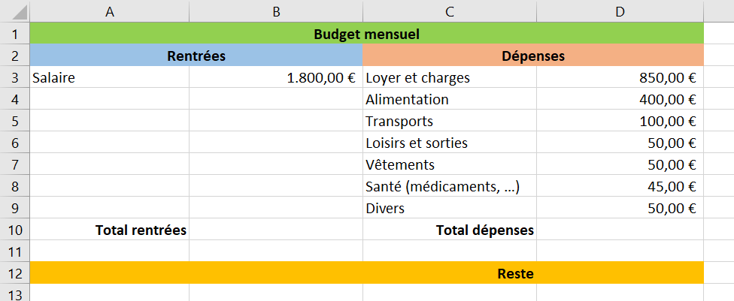
- Create a new spreadsheet document to recreate the table right below:

Then, do the following:
- Use the Sum formula to calculate the total of Entries (B10) and the total of Expenditures (D10).
- Establish a formula to calculate what is left at the end of the month (D12).

- Save it in your ICT Assessment 2020 folder by naming it « Budget Exercise ».

SAFETY & PRIVACY
- Is there an antivirus software on this computer?
- If so, what is its name?
- Say you need to create a new email account and want to use the safest password, to make sure no one can access your account. Which password would you use in the list below?
- A. carol82
- B. c@rol82
- C. LmAet5!
- Read the following sentences. Choose Yes or No if you agree, or not, with the decision that was taken.
 | YES | NO
I got an email from the bank agency requesting my credit card secret code. I answer by sending them my code. | ☐ | ☐
I received an email from a well know company, but from an unknown email adress. They ask me to click on a link to update my client info. I can trust the company and click on the link safely. | ☐ | ☐
I received an email from an unknown email address telling me I won a prize. The email contains a document in attachment. I delete the email and block its sender. | ☐ | ☐
On Facebook, I can post my personal address safely. | ☐ | ☐
For my computer battery to last, I plug the computer on the power outlet all the time. | ☐ | ☐
My neighbour just posted a news article on Facebook. I check if the info is right before I trust it, by comparing it to other news sources. | ☐ | ☐
When finding a random image or a picture in the Internet, I cannot necessarily modify and use it freely. | ☐ | ☐
Under an Instagram post, someone asks me to post my email address and password to take part to a giveaway. I comment with the info and cross my finger for the giveaway. | ☐ | ☐
I am at the beach and I just took a nice picture of the sea. On the picture, there are some people I don’t personally know and their children playing in the sand. I post it on Facebook and Instagram so that all my friends can see it. | ☐ | ☐

TO CONCLUDE…
When you completed all exercises:
- Take a screenshot of your ICT Assessment 2020 folder and insert it here:

- Save this document in PDF, by naming it “Digital assessment – your name”. Save it in your ICT Assessment 2020 folder.

- Send an email to xxx@xxx.yyy with this document (the PDF version) + your Budget Exercise spreadsheet.
In the “Subject” line of the mail, write your name + Digital assessment.

For the project, we made a crossover, halfway between version 2.0 and 2.1, which are complementary. Together they provide a common European reference framework. For more information, see https://ec.europa.eu/jrc/en/digcomp

