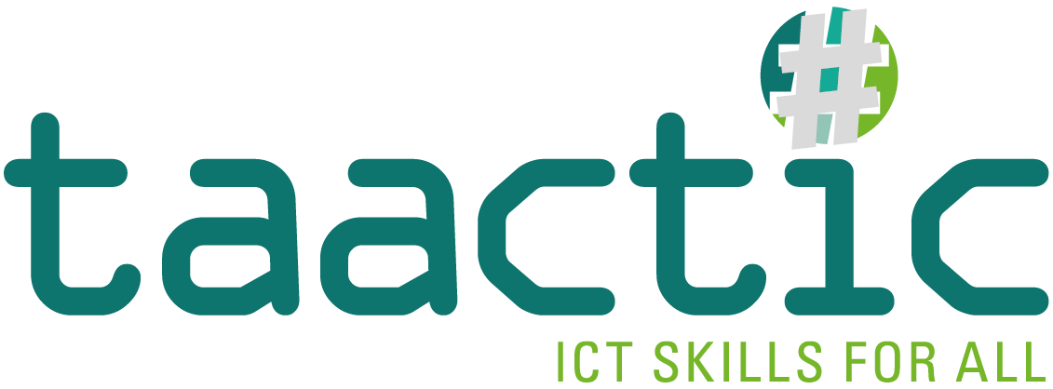

INTELLECTUAL OUTPUT 2

INTELLECTUAL OUTPUT 2

Learning Units

This work is licensed under a Creative Commons Attribution
– Non-Commercial – Share Alike 4.0 International License.
Only the text of this publication (not the illustrations) is available
under the license.

The European Commission’s support for the production of this publication does not constitute an endorsement of the contents, which reflect the views only of the authors, and the Commission can not be held responsible for any use which may be made of information contained therein.

TAACTIC - Project n°2019-1-FR01-KA204-063046

LEARNING UNIT 1 : COMPUTER ENVIRONMENT

LEARNING UNIT 1 : COMPUTER ENVIRONMENT

KNOWLEDGE | SKILLS | SOFT SKILLS
Essentials
Computer environment (computer, hardware, software) | Identify the part of a computer/ a laptop/ a smartphone/ a tablet | Learn to learn
Computer peripherals (webcam, usb, headphones,...) | Explain the basic terminology
Internet connection | Turn on/off a computer/ a laptop/ a smartphone/ a tablet
Basic computer commands | Type on a keyboard and use the mouse
Desktop and icons | Recognize desktop icons and windows basic applications
External components (scanner, printer,..) | Connect a computer to a wireless or fixed network
Basics on Internet access | Connect a smartphone to the internet
Operating systems (Windows,...) | Use the web-browser interface
Standard
 | Customize the welcome screen design
LEARNING HOURS
Total : 8 hours | Face to face : 80% | E-learning : 20%

LEARNING UNIT 2 : COMMUNICATION

LEARNING UNIT 2 : COMMUNICATION

KNOWLEDGE | SKILLS | SOFT SKILLS
Essentials
Understanding what an account represents and how to manage it | Create and manage a personal account (choosing a password, storing credentials,...) | Know the rules of conduct designed to foster mutual respect among users (netiquette)
How an e-mail works | Manage an e-mail address (contact list, attachments,...) | Use social networks for social purposes and job search
Communication programs (Whatsapp, Google meet, Skype, Zoom,...) | Set data security and privacy policies | Build a digital identity on social networks
Social networks (facebook, instagram,...) | Synchronize accounts and cloud spaces by managing their backups. | Communicate by verbal and non-verbal communication skills
Synchronization accounts |  | Create a profile in line with the principles of good social behavior
LEARNING HOURS
Total: 10 hours | Face to face: 80% | E-learning: 20%

LEARNING UNIT 3 : INFO SEARCH

LEARNING UNIT 3 : INFO SEARCH

KNOWLEDGE | SKILLS | SOFTSKILLS
Essentials
Understanding how the internet works | Know how to use Internet for research purposes | Evaluate reputable information and use a reliable source (fake news).
What are the search engines and what they are for | Search and find sites of interest (leisure, work, citizenship, health,...) | Search and find sites of interest (leisure, work, citizenship, health,...)
Search and find sites of interest (leisure, work, citizenship, health,...) | Search and find useful applications and tools for everyday life (maps, translations, purchases,...) | Use e-services for citizens - country-specific
 |  | Use e-services for citizens - country-specific
LEARNING HOURS
Total: 8 hours | Face to face: 70% | E-learning: 30%

LEARNING UNIT 4 : CONTENT CREATION

LEARNING UNIT 4 : CONTENT CREATION

KNOWLEDGE | SKILLS | SOFTSKILLS
Essentials
Using writing programs (Microsoft Word, Google Documents, LibreOffice or similar) | Know how to create and edit a text file | Know basic structure of useful documents. For example: curriculum vitae, timesheet,...
Using programs to create and manage spreadsheets (Microsoft Excel, LibreOffice Calc or similar) | Know how to create a worksheet and manage the main commands | Improve yourself: appearance, punctuality, oral and written expression...
 |  | Apply a Self-evaluation
Standard
Main programs for content creation (presentations, video and photo editing, etc...) | Know how to convert a file (e.g. from word document to pdf)
LEARNING HOURS
Total: 15 hours | Face to face: 70% | E-learning: 30%

LEARNING UNIT 5 : FILE MANAGER

LEARNING UNIT 5 : FILE MANAGING

KNOWLEDGE | SKILLS | SOFTSKILLS
Essentials
File storage and management (save, search, choice of the appropriate format,...) | Save and find files using fixed and removable memories | Manage the computer Security
File size, knowledge of units and possibilities to compress file format (zip) | Use the appropriate support to save files (internal memory, icloud space, hard-disk,...) | Protecte the privacy and the dissemination of sensitive data
Data management and tools to prevent data loss: backup | Know how to set up a file backup and recovery system | Apply a Self-evaluation
How file sharing works and how to manage a cloud space | Know how to share information with different tools (email, social, icloud,...)
LEARNING HOURS
Total: 8 hours | Face to face: 80% | E-learning: 20%

LEARNING UNIT 6 : SECURITY

LEARNING UNIT 6 : SECURITY

KNOWLEDGE | SKILLS | SOFTSKILLS
Essentials
Understanding the utility and working principles of an antivirus | Manage the updating of functional programs and the security of digital devices (antivirus) | Choose a secure password
Online purchases and working principles of electronic payments | Safely and securely manage of electronic payments | Build a digital identity and know potential risks of social media and how to share personal information on the Internet.
Understanding the importance of a correct shutdown of digital devices (logout, system updates,... | Recognize a malfunction and know how to seek assistance if necessary | Recognise a phishing scam
Dangerous Software malware, spam,...
LEARNING HOURS
Total: 8 hours | Face to face: 100% | E-learning: 0%

